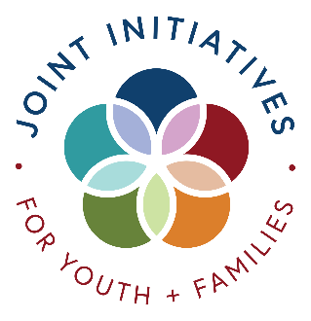

UNIVERSAL PRESCHOOL UPDATE
3.10.25

Purpose
This document offers Universal Preschool updates to local providers.
UPDATE
Today is the day that the next (and final) algorithm will run. You will not see matches until Wednesday sometime. The following are the timelines for this round:
March 10: Algorithm runs
March 12-21: Providers review matches and reach out to families to offer tours, discuss payments, etc. Providers can decline through the 21st provided that you have a reason in your set up form to decline the family.
March 24: Families can see matches and must either accept or decline by March 31st
April 1 through the rest of the year - Direct enrollment
Reminder: When you reach out to families about possible matches and tours, PLEASE let them know that they will not be able to see their match until March 24. Only you can see it before then.
ROUNTABLES
Next Roundtable: Will be March 20th at 11:00 AM and 6:00 PM. The zoom link is on the UPK page at www.jointinitiatives.org/upk. We will go through the direct enrollment steps and answer any other questions that you may have.
STATE OFFICE HOURS
Reminder that the state offers provider office hours twice a month:
- Community (including FCCH) Provider office hours with simultaneous Spanish interpretation have been scheduled as follows:
  - 1st Tuesday of each month at 6pm: us02web.zoom.us/j/83557451399
  - 4th Monday of each month at 1pm: us02web.zoom.us/j/88949693259

TUITION + CHARGES
Tuition and All Charges Must be Posted on Site: Reminder that providers are required to post on your profile your tuition and any charges that UPK families will be required to pay. If you have a program that is longer than 15 hours, you must post what you will charge families who are eligible for 15 hour free with UPK for the additional hours. If you have a program that is longer than 30 hours, you must also publish what you will charge families for the additional hours if they are eligible for 30 hours free with UPK. We have found several providers who have not published this, and families are surprised when they find out the cost. When calculating the costs for families, use the CURRENT UPK reimbursement rates (for this year). If you are provided an increase from the state, you can adjust prior to the start of the year.
Post these charges (as well as registration fees, etc.) in the Financial Programs Section under the Additional Payment Information text box.
STATE HELPDESK
The State Helpdesk is available. The information is below so you can refer families to it if they have a simple request. You are also free to make use of the Helpdesk. As always, Heather and I are here to help.
Parents, providers, and LCOs can now reach the help desk team by:
- Submitting a ticket request form: help.upk.colorado.gov
- Email: universalpreschool@state.co.us
- Call: 303-866-5223

Have a great week and thanks for all that you do for children and families!

